CSS – Cascading Style Sheet

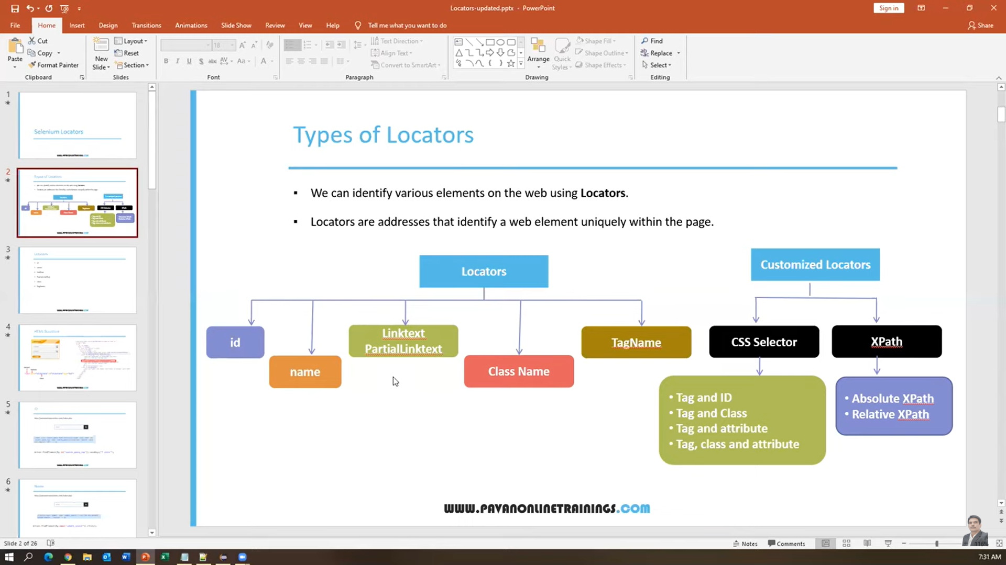

Different combinations

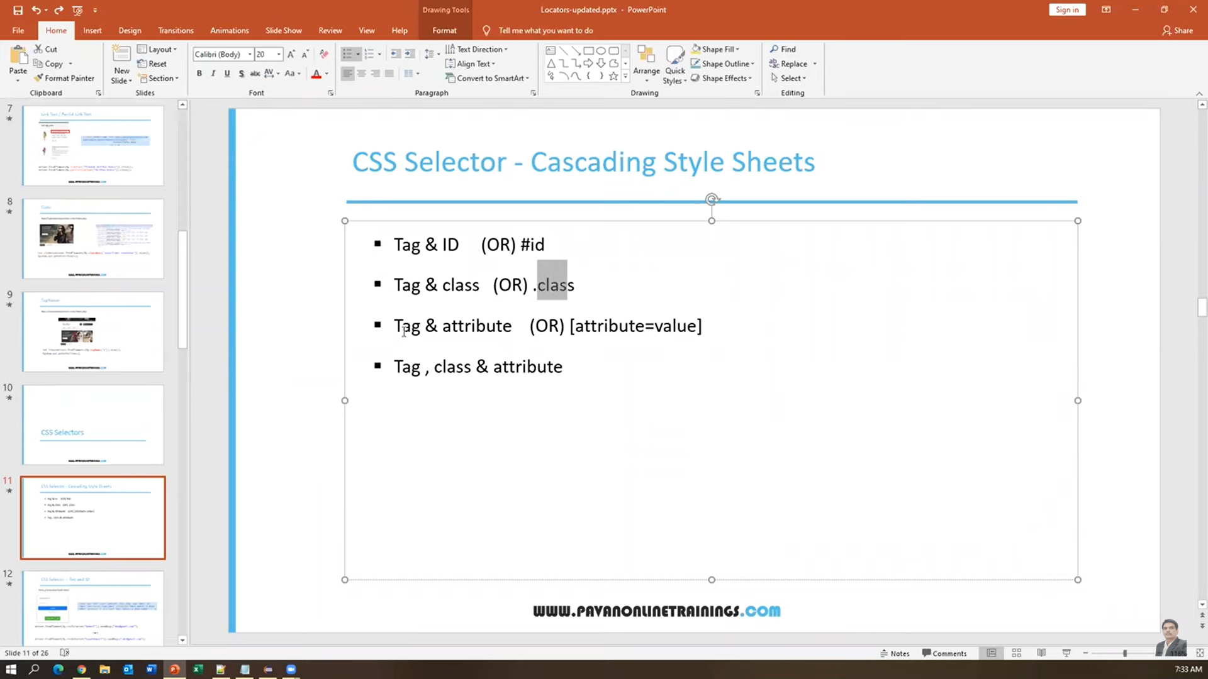

Tag and ID

Tag name is always optional

Tagname**#**ID

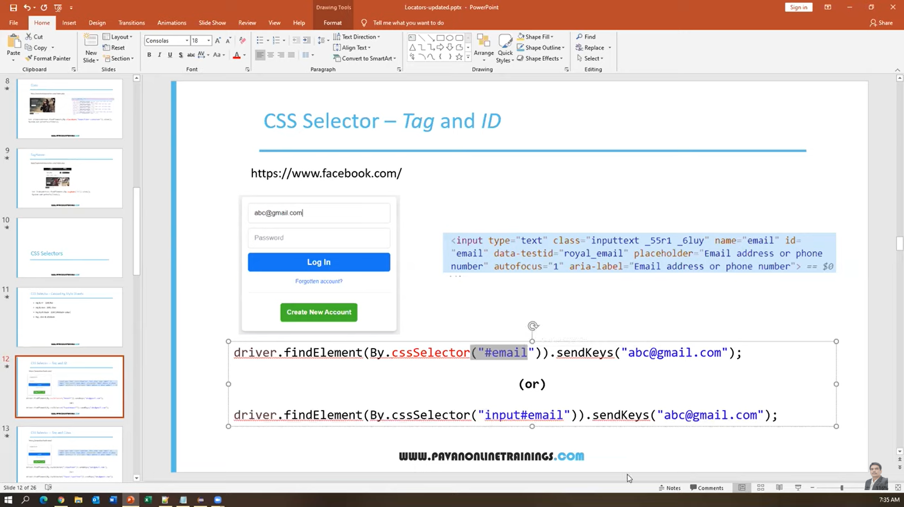

**Tag and Class**

Tag **.** Class

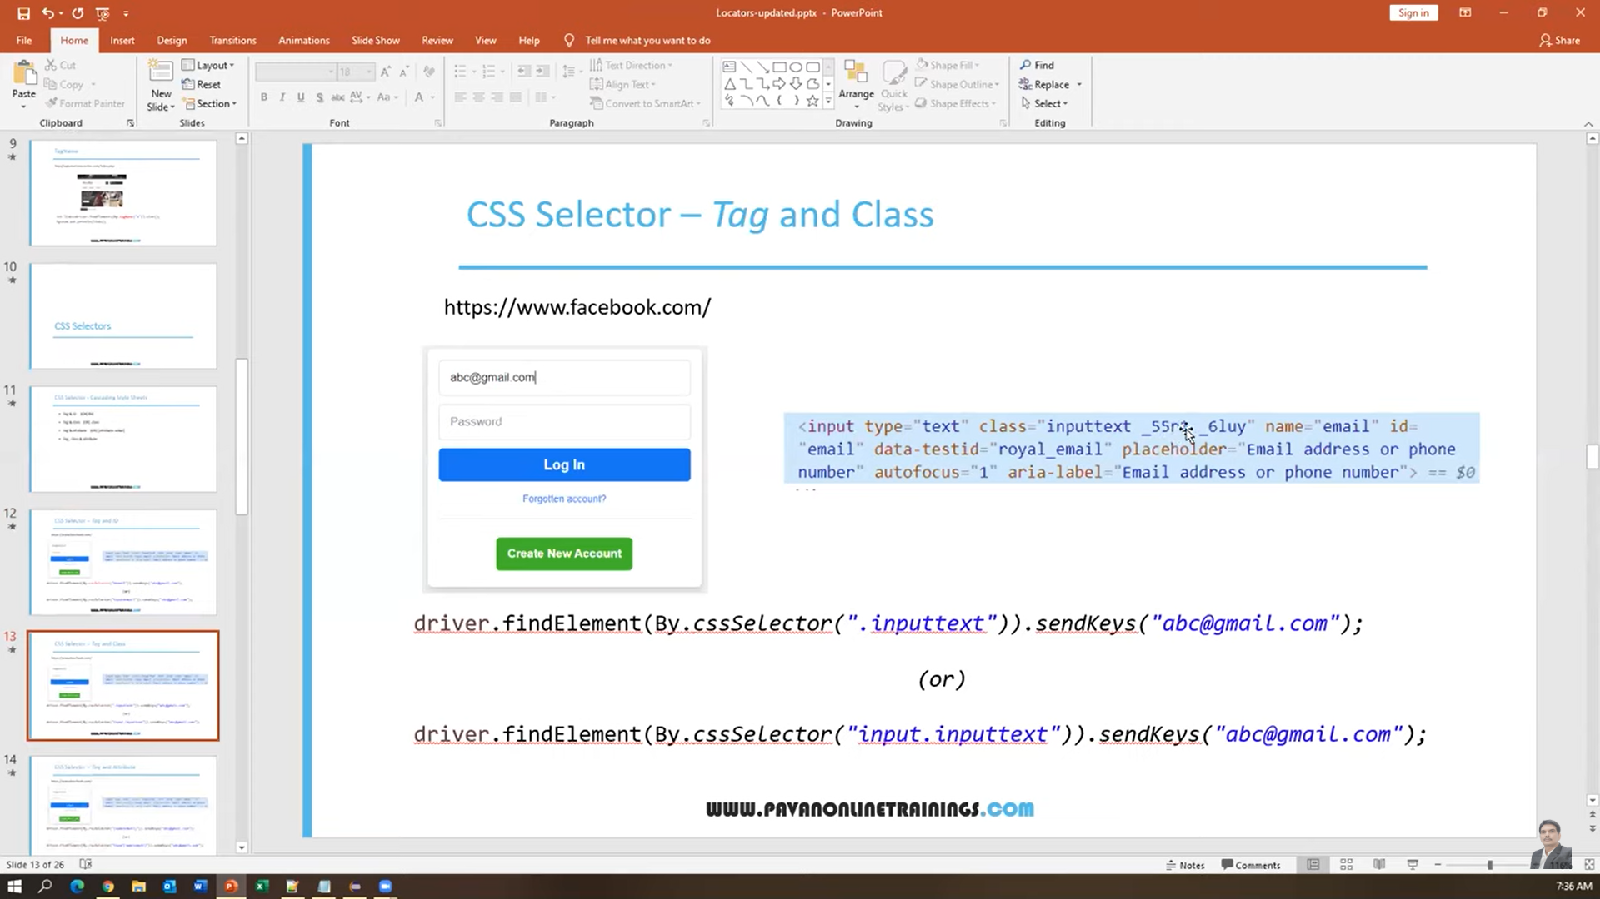

Tag and Attribute

Tag [attribute]

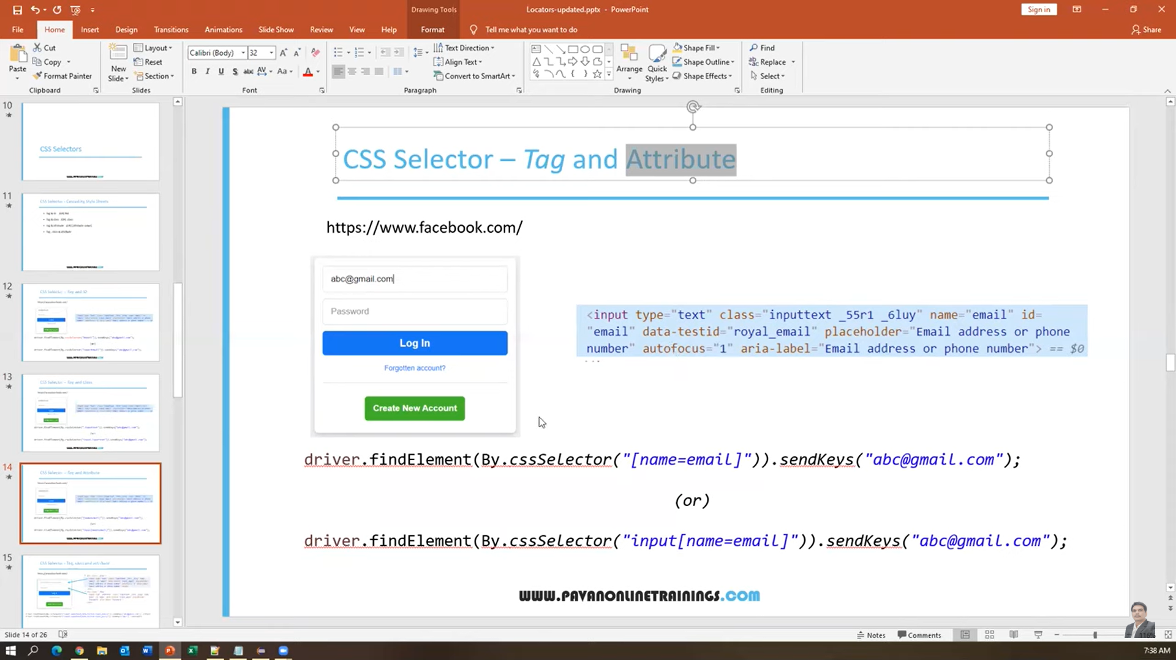

Tag Class and Attribute

